1.Installation

You need to download **IntelliJ IDEA Community Edition 2018.1.5** then install <https://www.jetbrains.com/idea/download/#section=windows>

After installation, you need to run **IntelliJ IDEA Community Edition 2018.1.5** (from desktop)

# 2. Creation of the simplest autotest Selenium + Java + Maven. Site [*http://automationpractice.com*](http://automationpractice.com)

# *2.1 file->new project->* Maven->Next ->

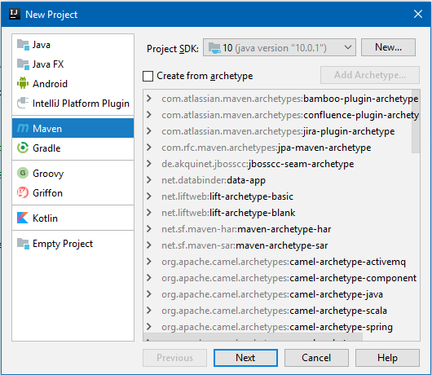

# Picture 1

# In the fields below, enter “FirstTest”->Next->Next

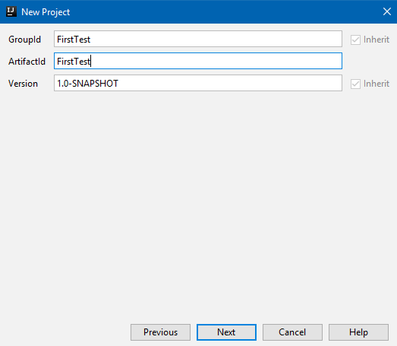

# Picture 2

# Open the “pom.xml” file and fill it up

<**dependencies**>  
 *<!-- https://mvnrepository.com/artifact/junit/junit -->* <**dependency**>  
 <**groupId**>junit</**groupId**>  
 <**artifactId**>junit</**artifactId**>  
 <**version**>4.12</**version**>  
 <**scope**>test</**scope**>  
 </**dependency**>  
 *<!-- https://mvnrepository.com/artifact/org.seleniumhq.selenium/selenium-java -->* <**dependency**>  
 <**groupId**>org.seleniumhq.selenium</**groupId**>  
 <**artifactId**>selenium-java</**artifactId**>  
 <**version**>3.14.0</**version**>  
 </**dependency**>  
  
</**dependencies**>

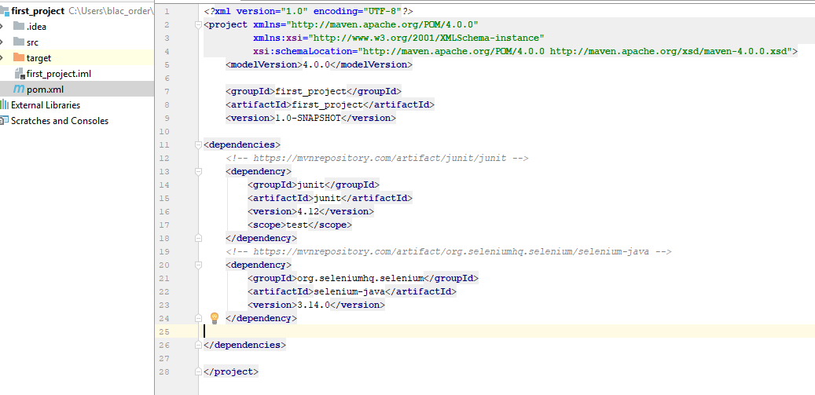

# Picture 3

# 2.2.To run tests in Google Chrome, in addition to the Selenium WebDriver library, you need to have and run a special executable file that acts as a bridge between the browser and the driver. The executable itself is called "chromedriver" and can be downloaded from *http://chromedriver.chromium.org/downloads* After downloading the executable file, you need to set its location. Without this, when initializing the driver

*System.setProperty("webdriver.chrome.driver","C:/Users/nameUser /Downloads/chromedriver.exe");*

**Cоздаём класс** FirstTest

**package** com.automationpractice;  
 **import** org.junit.After;  
 **import** org.junit.Before;  
 **import** org.openqa.selenium.chrome.ChromeDriver;  
  
**public class** WebDriverSettings {  
 *// Create a new instance of the ChromeDriver driver  
 // Notice that the remainder of the code relies on the interface,  
 // not the implementation.* **public** ChromeDriver **driver**;  
  
 @Before  
 **public void** setUp() {  
 System.*setProperty*(**"webdriver.chrome.driver"**,**"C:/Users/blac_order/Downloads/chromedriver.exe"**);  
 **driver** = **new** ChromeDriver();*//chrome driver* System.***out***.println(**"Test start"**);  
 }  
  
 @After  
 **public void** close() {  
 System.***out***.println(**"Test close"**);  
 **driver**.quit();  
 }  
}

class*WebDriverSettings* starts the server process *WebDriverSettings* when it is created and ends it when the command is called quit.

**package** com.automationpractice;  
  
**import** org.junit.After;  
**import** org.junit.Assert;  
**import** org.junit.Before;  
**import** org.junit.Test;  
**import** org.openqa.selenium.By;  
**import** org.openqa.selenium.WebElement;  
**import** org.openqa.selenium.chrome.ChromeDriver;  
  
**public class** FirstTest **extends** WebDriverSettings {  
  
 @Test  
 **public void** firstTest() {

// And now use this to visit **automationpractice.сom**  
 **driver**.get(**"http://automationpractice.com"**);  
 String title = **driver**.getTitle();  
 Assert.*assertTrue*(title.equals(**"My Store"**));  
 }  
  
 @Test  
 **public void** secondTest() {  
 WebElement category = **driver**.findElement(By.*partialLinkText*(**"category"**));  
  
 }  
}

Autotest result

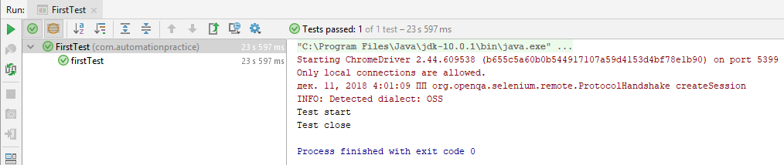

# Picture 4